**LAB 07 TASK 1**

**Sequence Diagram of ATM**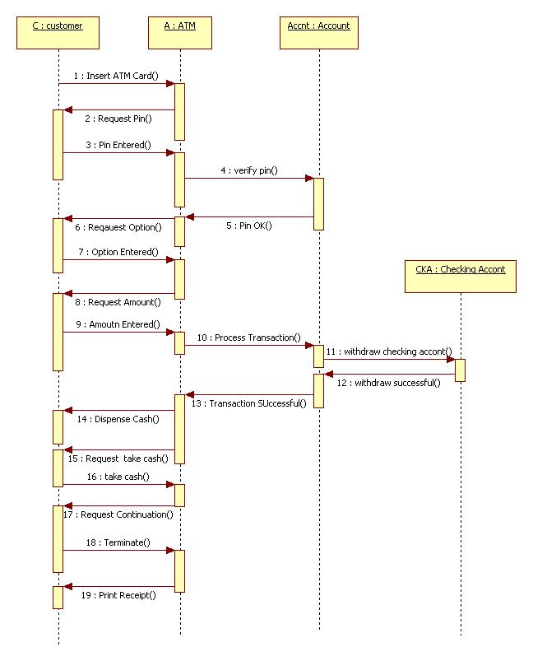

**LAB 07 TASK 2**

**Collaboration Diagram of ATM**

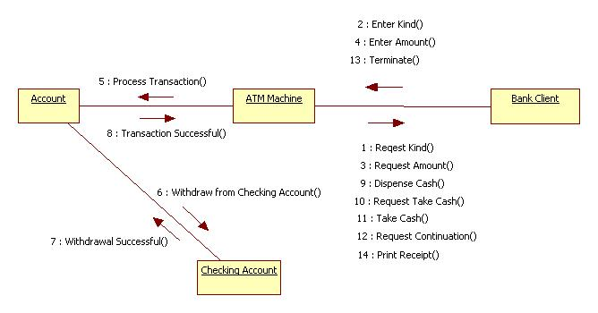

Sequence Diagram of Library Management System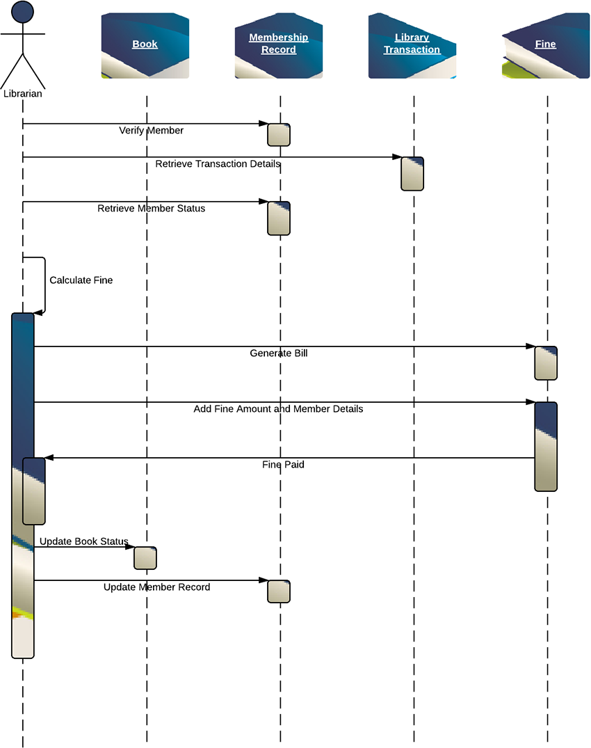

Collaboration Diagram of ATM

